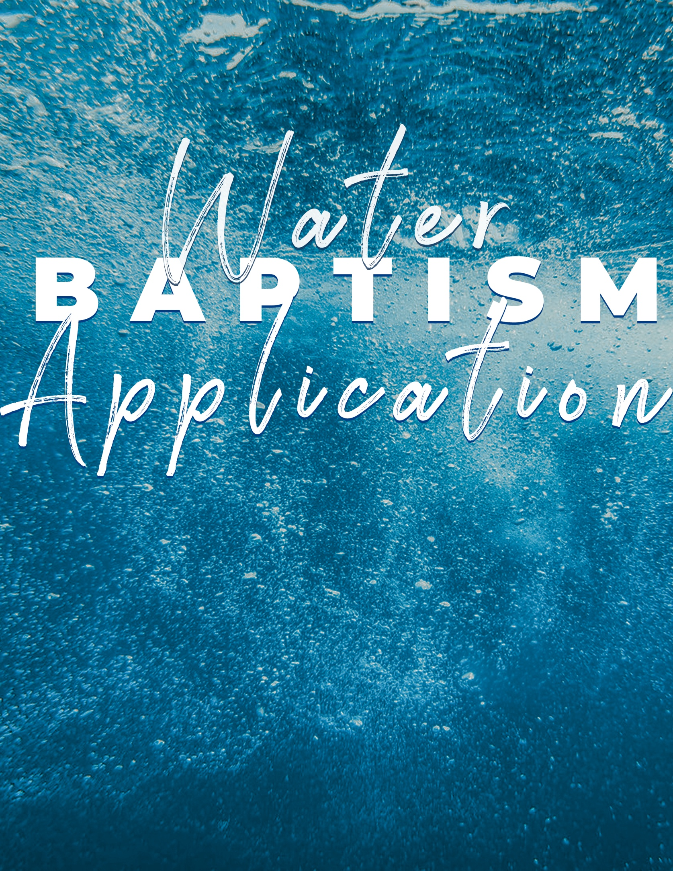

Water Baptism Application
Date

PROCESS OF BEING BAPTIZED:
Fill out & turn in Water Baptism Application
Attend a Pre-Baptism Class (Sign up at Info Center)

Full Name: DOB: Mailing Address: Phone: Text: Y / N
Email: Group/Class Leader: Have you ever been baptized by immersion before? If yes, in which church?

ABOUT
Date I received Christ as my Savior: What I did to receive Christ:

How I know I am forgiven and on my way to heaven:

How my life changed since accepting Christ as my Savior:

What/who God used to bring me into a relationship with Jesus:

Why I want to be baptized:

What does it mean to be baptized?

Write out a brief personal testimony about your faith in Jesus, to be read at your baptism. You can use answers from the questions above. It should include how you came to trust in Jesus and how God has changed your life. It could include evidence of your changed life, favorite scripture verses, and powerful personal stories. (If you need more room, you can use the back of this page).

School-Aged Children Parental Permission:
I do consent to his/her decision to be water baptized by immersion. I will attend the class with them and discuss water baptism. I see evidence of my child’s salvation since conversion by their obedience, repentance, and heart towards God in desiring to please Him. (Note: We recommend that the age of twelve and up is a good age for understanding the significance of their baptism experience.)

Parent/Guardian Signature: Phone:

TURN THIS APPLICATION INTO THE INFO CENTER OR CHURCH OFFICE

