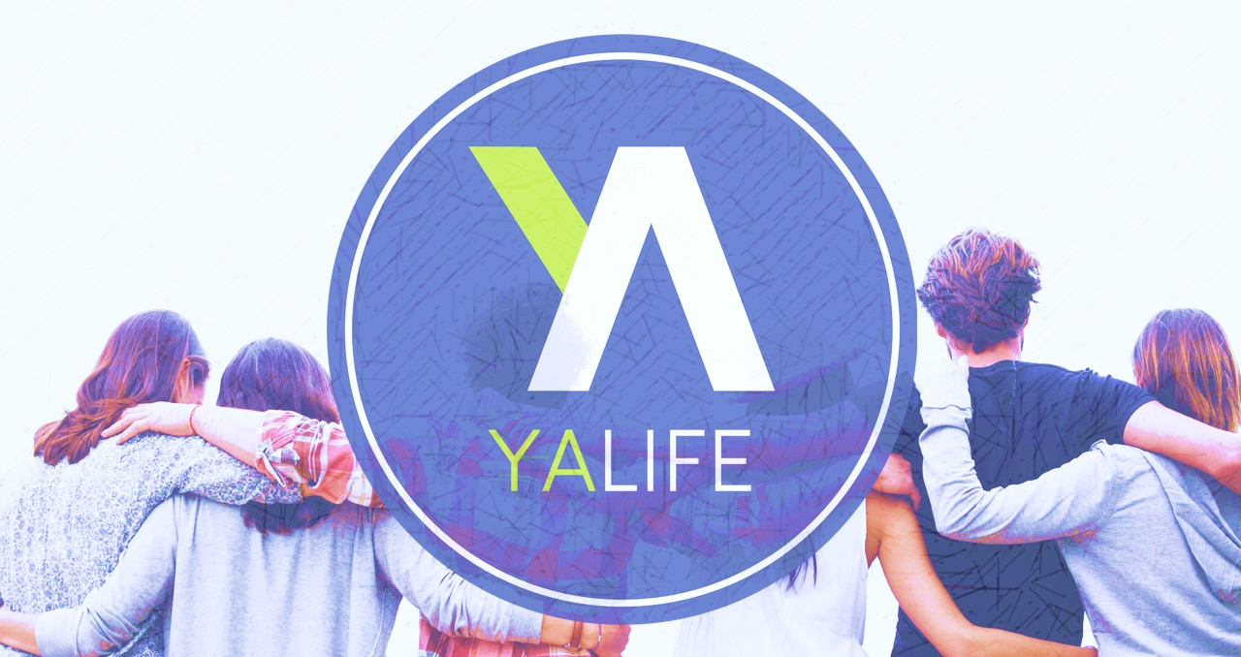

Monthly Events 2017

January 27-28 In Town Winter Retreat
Feb 5 Super Bowl Party/Food Contest
Feb 24 Fellowship Night
March 31 Hike
April 28 Kickball at Fuller Park
May 17 Police Dinner
June 2 Grad Bash
July 21 TBA
August 18-19 Summer Retreat
September 22 Bon Fire/Worship Circle
October Corn Maze
November 17 Harvest Party
December 15 Christmas Party
December 31 New Year’s Party

